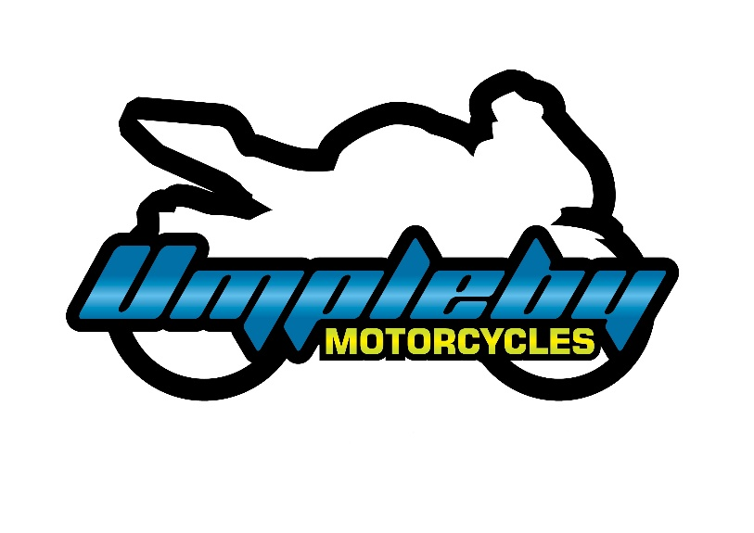
Suzuki Motorcycles Durban T/A Umpleby
Motorcycles
31B Roadhouse Crescent, Briardene,
Durban North
4051
TEL: 031 303 8323
Email: jarred@motocycle.co.za
CK 2024/083413/07

Required documents for Private Finance

Kindly send us:
- A copy of your valid motorcycle license/ motorcycle learner’s permit
- Your salary slips from the last 3 months
- Bank statements from the last 3 months
- Proof of address
- A clear copy of your valid ID

Please note that without the above documents, we are unable to proceed with your purchase.

